Sheet 3

Computing algorithms
Q1:Use the informal definitions of O,$θ$ ,$Ω$ and to determine whether the following assertions are true or false.
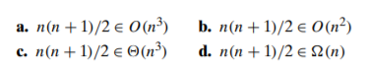
Q2.
Solve the following recurrence relations.
- $x\left(n\right)=x\left(n-1\right)+5for n>1,x\left(1\right)=0$
- $x\left(n\right)=3x\left(n-1\right)for n>1,x\left(1\right)=4$
- $x\left(n\right)=x\left(\frac{n}{3}\right)+1for n>1x\left(1\right)=1$
- $x\left(n\right)= 2x(n/2) + n for n > 1, x(1)=1$
- $x\left(n\right)=x\left(n-3\right)+3 for n>1, x\left(1\right)=0$
- $x\left(n\right)=$ 2x(n-2) +2 for n> 1, x(1)= 0
Q3.
